**React Fundamentals**

* Environment setup
* Function and class comp
* States &Props
* Event handlers
* Form handling & validation
* CSS & Bootstrap styling
* Re-usable components
* Lifecycle methods vs hooks

Install node JS from <https://nodejs.org/en/>

Visual studio code : <https://code.visualstudio.com/>

Install React extension “**ES7 React/Redux/GraphQL/React-Native snippets**” in VSCode.

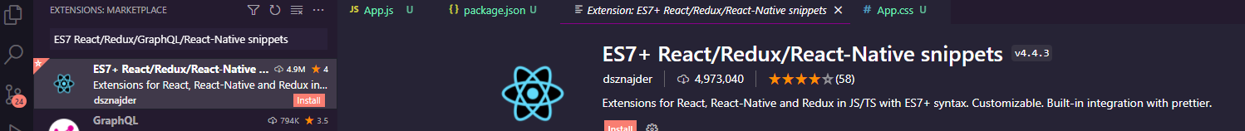

Prettier - Code formatter

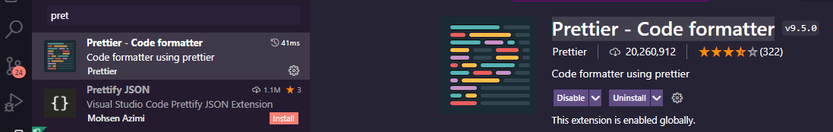

With above extension, we can format code and we can add code with simple commands.

Example if want to create a function use rfc

Install react app

C:\learning\react> npm install create-react-app

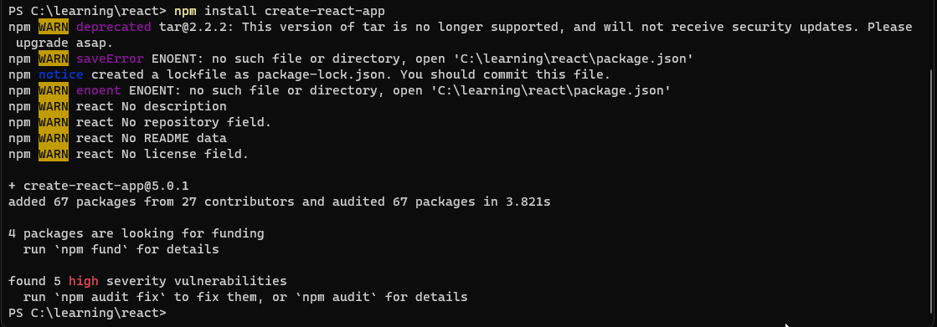

Create your app

npx create-react-app myapp

PS C:\learning\react\code> npx create-react-app myapp

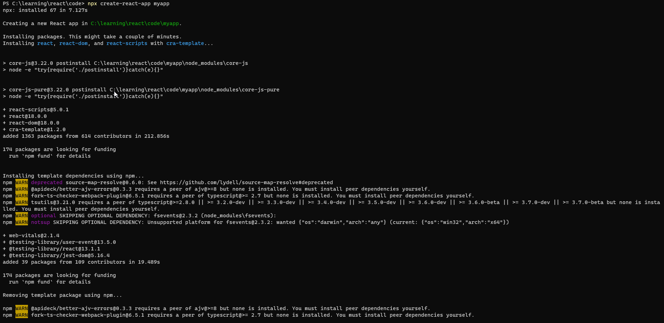

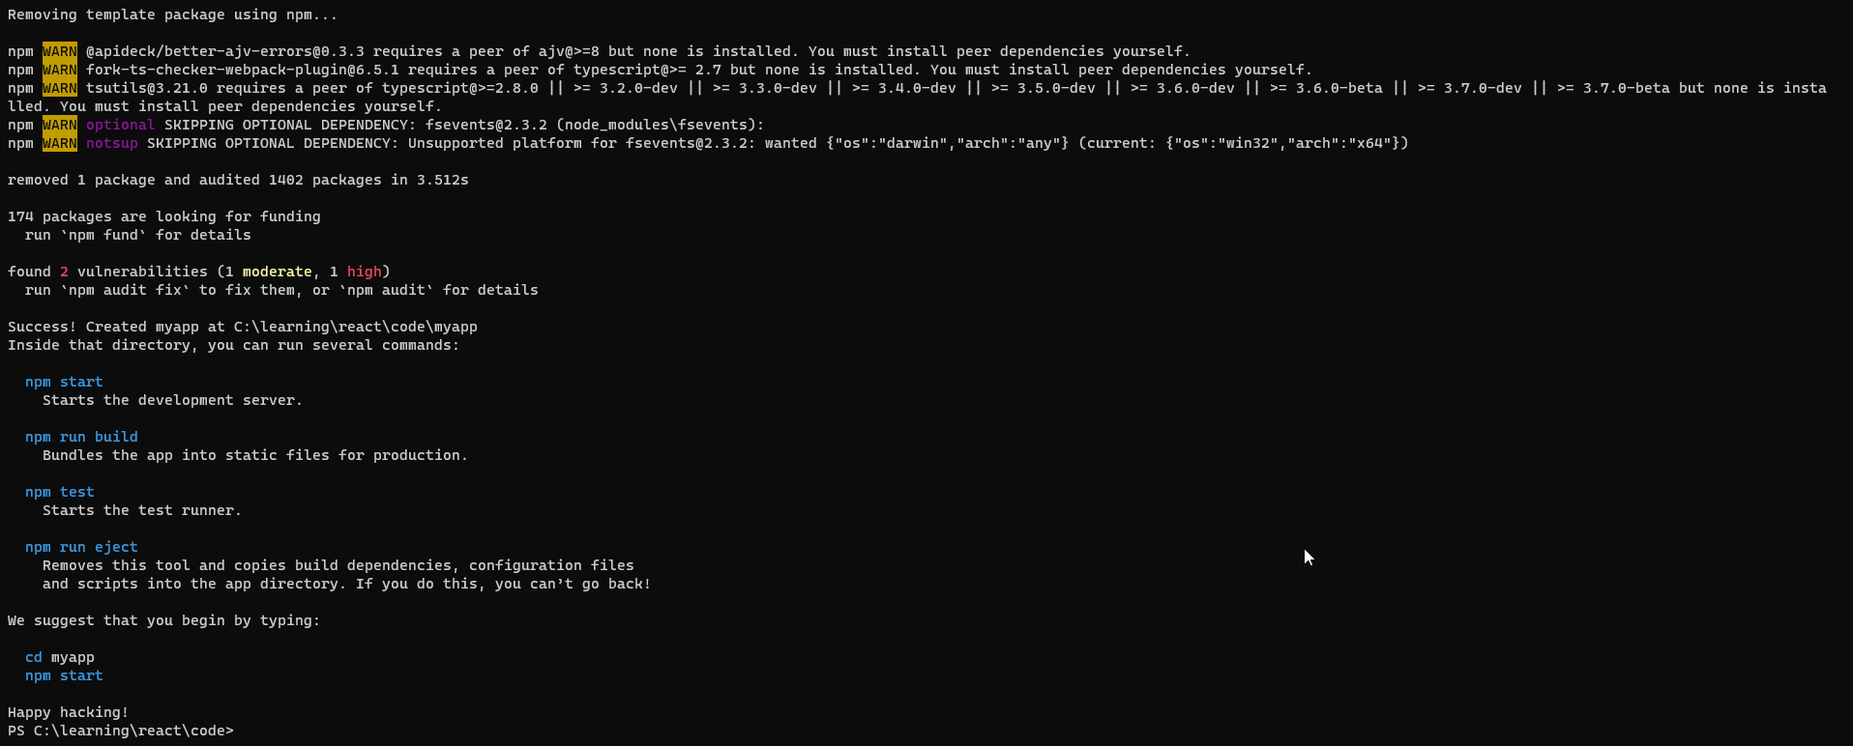

Cd myapp

npm start